Task 1:
Creating an Inbound Firewall Rule to Block Port 8080

Objective: Configure Windows Defender Firewall with Advanced Security to block all incoming connection requests on TCP Port 8080 across Domain, Private, and Public network profiles.

1. Step-by-Step Configuration Guide:
1.Open Advanced Firewall Management Console:Step 1.
Press Win + R, type wf.msc in the Run window, and press Enter to launch Windows Defender Firewall with Advanced Security.
2.Launch New Inbound Rule Wizard:Step 2.
In the left navigation pane, right-click on Inbound Rules and click New Rule....
3.Select Rule Type:Step 3.
Choose Port as the rule type and click Next.
4.Configure Protocol and Port Number:Step 4.
- Select TCP protocol.
- Select Specific local ports and enter 8080.
- Click Next.
5.Set Block Action:Step 5.
Select Block the connection and click Next.
6.Select Profile Scope:Step 6.
Ensure all three network profile checkboxes (Domain, Private, Public) are checked, then click Next.
7.Name and Save Rule:Step 7.
Set the rule Name as Block_Inbound_Port_8080 and click Finish.

2. Verification Command:
Open Command Prompt as Administrator and run the following command to verify the active firewall rule:

netsh advfirewall firewall show rule name="Block_Inbound_Port_8080"

Task 2:
Network Address Translation (NAT / PAT) Simulation & Analysis

Objective: Simulate and explain Network Address Translation (NAT) and Port Address Translation (PAT) showing how a home Wi-Fi router maps multiple internal private IP addresses (Phone, Laptop, Smart TV) to a single globally routable public IP address for internet access.

1. Text-Based NAT / PAT Architecture Diagram:

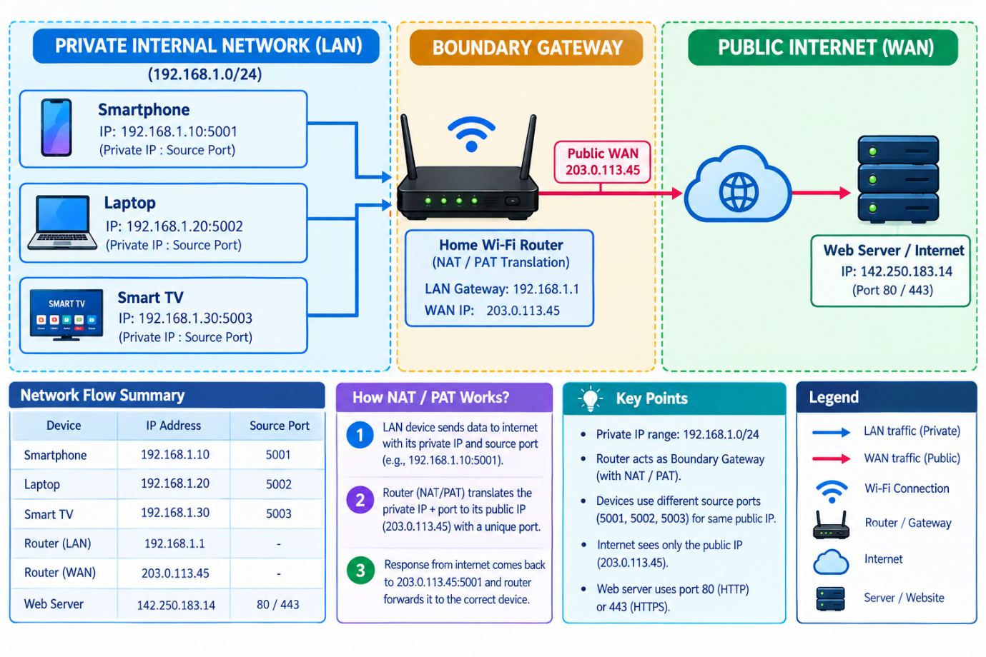
2. Router NAT Translation Table (PAT Mapping):
Device Name | Private Source IP & Port (LAN) | Translated Public IP & Port (WAN) | Destination IP & Port (Internet) | Protocol
Smartphone | 192.168.1.10:5001 | 203.0.113.45:40001 | 142.250.183.14:443 (HTTPS) | TCP
Laptop | 192.168.1.20:5002 | 203.0.113.45:40002 | 172.217.166.78:80 (HTTP) | TCP
Smart TV | 192.168.1.30:5003 | 203.0.113.45:40003 | 142.250.183.100:443 (Streaming) | TCP

3. How NAT Works (Step-by-Step Explanation):
1.Outbound Request Generation:Step 1.
Internal host endpoints (e.g., Laptop at 192.168.1.20) initiate outgoing HTTP requests destined for a public web server IP.
2.NAT Header Rewrite at Gateway:Step 2.
When the Ethernet frame reaches the router, the NAT engine replaces the internal private source IP (192.168.1.20) with the single WAN public IP (203.0.113.45) and assigns a unique source port number (e.g., 40002).
3.NAT Table Entry Logging:Step 3.
The router records this mapping entry in its active NAT translation memory table to keep track of which response packet belongs to which specific internal device.
4.Inbound Response De-translation:Step 4.
When the web server sends response data back to 203.0.113.45:40002, the router looks up its NAT table, rewrites the destination IP back to 192.168.1.20, and delivers the packet directly to the Laptop.

Task 3:
Outbound Port Filtering Configuration (Port 25 SMTP)

Objective: Configure port filtering rules on the router boundary gateway to block outbound communication over TCP Port 25 (Simple Mail Transfer Protocol - SMTP) and prevent unauthorized spam distribution from infected local devices.

1. Step-by-Step Configuration Guide (Router Admin Panel):
1.Access Router Admin Panel:Step 1.
Open a web browser and navigate to the local router IP (e.g., 192.168.1.1 or 192.168.0.1), then log in with administrator credentials.
2.Navigate to Port Filtering Settings:Step 2.
Go to Security > Access Control (or Firewall > Port Filtering / IP & Port Filter Rules).
3.Create Outbound Blocking Rule:Step 3.
Click Add New Rule and configure the following parameters:
- Rule Name: Block_Outbound_SMTP_Port_25
- Direction: Outbound (LAN to WAN)
- Protocol: TCP
- Destination Port Range: 25
- Source IP Range: 192.168.1.2 - 192.168.1.254 (All LAN hosts)
- Action: Deny / Block
4.Save and Apply Settings:Step 4.
Click Save / Apply and restart the firewall service to activate the port filter.

2. Anti-Spam Explanation (Exact 2 Sentences):
Blocking outgoing traffic on Port 25 prevents malware or botnets on compromised internal devices from silently sending bulk unencrypted spam emails directly to external mail servers. This ensures the network's public IP address maintains a clean reputation and does not get blacklisted by global email service providers.

Task 4:
Packet Filtering Rule Set Analysis & Packet Inspection

Objective: Evaluate three sample network traffic packets against a standard firewall packet filtering access control list (ACL) to determine if each traffic flow is ALLOWED or BLOCKED.

1. Standard Baseline Firewall Rule Set (ACL Table):

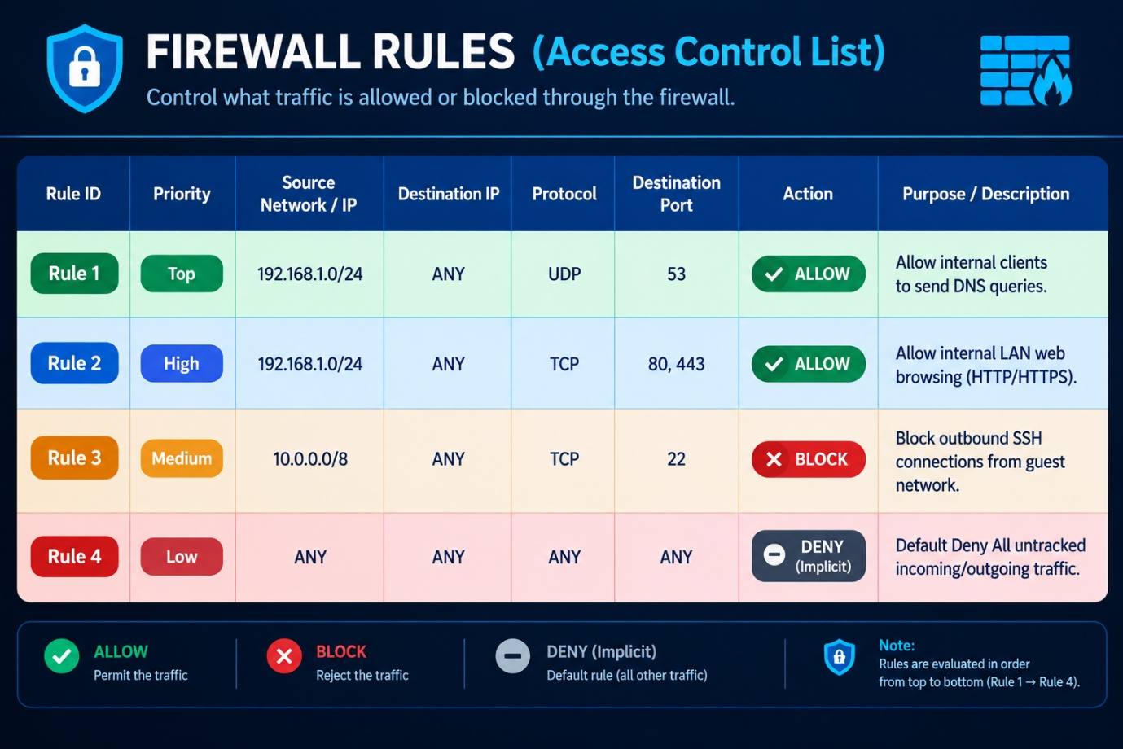

2. Packet Evaluation & Inspection Results:
Packet 1: HTTP Request
- Source IP: 192.168.1.5 | Destination IP: 172.217.166.78 | Port: 80 (TCP)
- Rule Matched: Rule 2 (192.168.1.0/24 -> Port 80 ALLOW)
- Final Status: ALLOWED
- Reason: The source IP belongs to the local LAN (192.168.1.0/24), and destination port 80 (HTTP) is explicitly permitted by Rule 2 for outbound web browsing.
Packet 2: SSH Request
- Source IP: 10.0.0.10 | Destination IP: 34.201.23.1 | Port: 22 (TCP)
- Rule Matched: Rule 3 (10.0.0.0/8 -> Port 22 BLOCK)
- Final Status: BLOCKED
- Reason: Traffic originates from the 10.0.0.0/8 subnet attempting connection over Port 22 (SSH), which matches the explicit security block on Rule 3 to prevent unauthorized remote management access.
Packet 3: DNS Query
- Source IP: 192.168.1.7 | Destination IP: 8.8.8.8 | Port: 53 (UDP)
- Rule Matched: Rule 1 (192.168.1.0/24 -> Port 53 ALLOW)
- Final Status: ALLOWED
- Reason: The packet matches Rule 1, allowing internal hosts on 192.168.1.0/24 to resolve domain names via public DNS servers (Port 53 UDP).

Task 5:
Enterprise Firewall & Packet Filtering Use Cases (Instagram / Zomato)

Objective: Research and document 3 primary strategies through which high-traffic cloud applications (e.g., Instagram or Zomato) deploy advanced Web Application Firewalls (WAF) and packet filtering mechanisms to prevent service disruption, malicious scraping, and cyber attacks.

1. 3 Enterprise Protection Strategies:
1. Mitigating Distributed Denial of Service (DDoS) Attacks
- Mechanism: Enterprise Edge Firewalls (e.g., Cloudflare, AWS Shield) inspect inbound traffic streams at Layer 3 (Network) and Layer 4 (Transport).
- Implementation: During peak order hours on Zomato or viral post spikes on Instagram, packet filters monitor traffic volume per IP. If an IP address sends an anomalous flood of SYN packets or ICMP requests, the firewall dynamically drops those malicious packets at the network edge before they reach internal application servers.
2. Rate Limiting to Prevent API Misuse & Web Scraping
- Mechanism: Web Application Firewalls (WAF) filter incoming Layer 7 (Application) HTTP/HTTPS API calls based on request rate limits per user session or IP address.
- Implementation: Instagram uses application layer packet filtering to detect automated bots attempting to scrape user profile data or spam comment APIs. If a single IP makes more than 100 API calls per minute, the firewall automatically blocks or throttles traffic from that source IP.
3. Blocking Malicious Web Exploits (SQLi & XSS Prevention)
- Mechanism: Deep Packet Inspection (DPI) firewalls analyze the actual payload content of incoming HTTP POST/GET requests.
- Implementation: When users input data on Zomato (e.g., delivery address, search queries) or Instagram (e.g., captions, comments), the WAF filters out requests containing malicious SQL commands (SQL Injection) or script tags (Cross-Site Scripting - XSS) to prevent unauthorized database tampering and account takeover attacks.

2. Summary Table:
Security Defense Level | Firewall Technology | Targeted Threat / Attack Type | Protective Outcome
Layer 3 / 4 (Network) | Cloud Edge DDoS Firewall | Volumetric DDoS / SYN Floods | Maintains uninterrupted app uptime and server availability.
Layer 7 (Application) | API Gateway Rate Limiting | Bot Scraping & Brute-Force Spam | Prevents API resource exhaustion and unauthorized data scraping.
Payload Inspection | Web Application Firewall (WAF) | SQL Injection (SQLi) & XSS | Protects user database records and sensitive financial transactions.

